1. Link bài:'I wanted to make a change knowing older people suffer from loneliness' | Volunteering | The Guardian (Quỳnh)

'I wanted to make a change knowing older people suffer from loneliness'
To celebrate Volunteers’ week we’re profiling some of the people who give up their time to help and inspire others
Guardian readers and Rachel Obordo
Mon 4 Jun 2018 13.05 BST

One of the most memorable volunteering moments for Loraine Coleman was when she received a call from another volunteer who works for the Metropolitan police.
“Loraine, I’ve found a pair of false teeth in the back of my car ... What do I do?”
“Well, give them back. I assume they aren’t yours? Who did you take home after the tea party?”
“Er, Peggy, Joan and Alan...”
“Well there’s your answer.”
“What do you mean? What should I do?”
“You’re the detective!”


Coleman, 62, from Thurrock always planned to volunteer with older people when she retired: “I knew there was such a big gap in the care and support this generation receive and I found the thought heartbreaking - no one should have to feel lonely and stuck at home.”
Since she started volunteering with her husband Mick for Contact the Elderly in 2015, her team of volunteers have set up seven groups in Thurrock. By hosting tea parties for groups of ten, for those aged 75 and older who live on their own, Coleman and her team regularly provide support, friendship and companionship for almost 80 of the most isolated older people in the community.
“Working with my older neighbours is very rewarding and a lot of fun,” she says. “To hear their stories, the hardships they have overcome, and their experiences and lessons, is inspiring. I feel like I’m making a positive difference to the lives of other by sharing my time with them, helping older people stay active, social and making clear to them they are valued by our community.”
As an area coordinator, Coleman helps organise social events and recruits and manages volunteers, without whom none of the work would be possible: “The 63 volunteers we have are truly incredible and are a constant source of inspiration for me. So many go above and beyond what’s asked, giving their time, energy and kindness, just because they care. I’ve found so much enthusiasm from people wanting to make the lives of our older neighbours better.
“I’ve met so many amazing people from all walks of life. It’s one of the best things I’ve ever done and it’s enriched my life so much. I feel very much a part of a growing charity that focuses on reducing loneliness and isolation with our elderly. Our ageing population will require much support over the years and I am looking forward to this challenge and making a difference by helping today’s generation of older people live and enjoy the old age that they deserve.”

2. Link bài: Kindness Bag Changes Homeless Vet's Life, Now He Delivers Them on LA Streets - Good News Network (Quỳnh) có link Ytb ở dưới

Kindness Bag Changes Homeless Vet’s Life, Now He Delivers Them on LA Streets
By Good News Network -
Jan 19, 2015

Many people in America mark the Martin Luther King Day holiday by making it a day of service – painting schools, cleaning parks and helping the homeless. But, volunteers for a group called The Giving Spirit work throughout the year in Los Angeles personally distributing survival kits to people living on the streets.
“There is so much in this bag,” one recipient told a volunteer. “Everything on my list that I prayed for is in here! How did you know exactly what we need?”
Ezzie Richey, a 57-year-old homeless veteran was one of those who was given a duffel bag containing over 60 items, like food, blankets, clothing and toiletries. He not only was grateful for the bag, but for the love and hope that came with it. The moment so influenced his life that he is now off the streets and employed.
Now he is giving back as a volunteer, handing out bags with the nonprofit group’s founder, Tom Bagamane, who has become a good friend.
The Giving Spirit, founded in 1999, is always looking for in-kind donations of items to include in their kits. Check the list on their website to see what items you or your company might provide to help the effort.
The LA Times caught up with Ezzie and featured his story in a video and feature article.
(WATCH the video below and READ the story from the LA Times)
Formerly homeless vet takes his survival story to the streets
Story tip from Jacqueline McLean – Jones
3. (Link bài ) (pa) https://www.theguardian.com/lifeandstyle/2019/nov/03/i-was-given-a-second-chance-six-amazing-people-describe-their-life-changes

“I was given a second chance”: six amazing people describe how their lìfe change forever
(Sun 3 November 2019)
The guardian.com
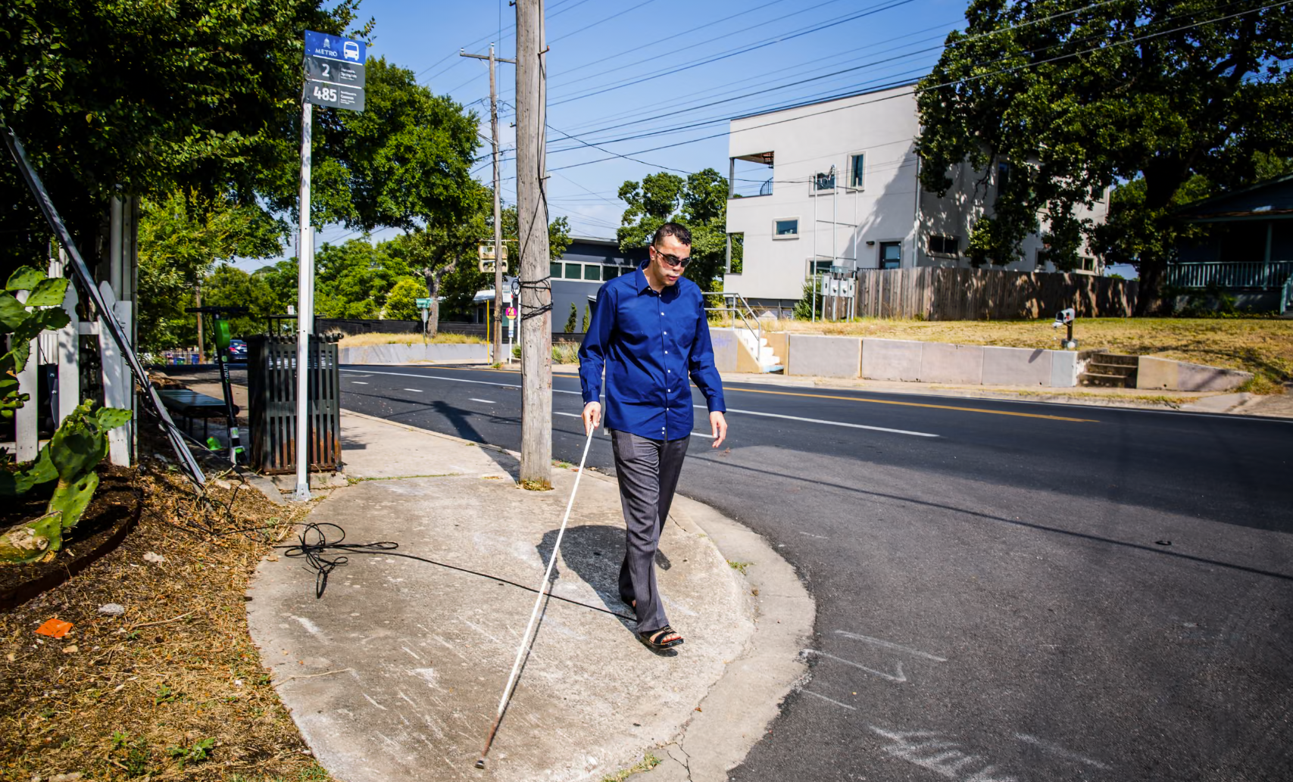

The evening of 3 August 2006 was like any other. My friends and I were playing volleyball and a crowd had gathered to cheer us on. Towards the end of the match, I noticed a small truck coming towards us. I didn’t think much of it; people often drove up to watch us, and there was a place to grind wheat for flour close by. As the truck grew closer it got stuck in the sand. The driver, a man in his 50s or 60s, revved the engine heavily, and suddenly he was coming up close behind me. I jumped out of the way, as it looked as if he might crash into me. I caught his eye, he looked left and then right, and then directly at me with a smile. He pushed his hand down on the horn, and instead of honking, a whirring began.
Everything went dark at that point: just the red of the fire as people and cars flew through the air like birds. I was thrown upwards with the explosion, falling back to earth through the smoke headfirst. All I could see was smoke, and the blood flowing from my nose. All I could think to do was run, but as I stood up I was hit by shrapnel in the head. I lost control of my body and collapsed. There and then I lost my sight.
A few minutes later I heard my father’s voice. He was crying. I told him not to leave me else I would die. At the clinic the doctor told him I would be dead within 30 minutes. Thankfully I didn’t die, and soon my father was driving me to a hospital in downtown Mosul, a journey of 70 or 80 miles. En route we were stopped by American soldiers. I had no idea what was going on when they put a medical shot in my back, nor when I heard the sound of a helicopter approaching. I went into a coma for 12 days.
When I woke up an interpreter asked my name. I told her: Qusay. She thanked God I knew it, which I didn’t understand. I had no recollection of what had happened. As soon as she mentioned the explosion everything came back to me. If the shrapnel had hit my head just one hair’s width differently I’d have lost my entire memory. That, she told me, is why she thanked God.
My family assumed I’d died and were already in mourning. When my father received the call from the Americans 14 days later he didn’t believe I’d survived. He thought someone was trying to lure him towards danger. It was only when they mentioned the tattoo on my arm – my name – that he could let himself accept it.
Neither Iraqi doctors nor the US soldiers had the resources to help me heal, so for the following months I struggled, to breathe, to eat, to live. I had no nose, no cheek, half my skull was missing….
https://www.youtube.com/watch?v=8t07V5aCcME (link youtube trực tiếp về cuộc đời của Qusay Hussein từ kênh YT: Doctors without borders/ MSF-USA)

4.https://en.nhandan.vn/500-day-and-night-campaign-dna-testing-results-returned-for-nearly-800-samples-of-martyrs-remains-post167905.html

500-day-and-night campaign: DNA testing results returned for nearly 800 samples of martyrs’ remains
After seven months of the 500-day-and-night campaign, relevant units have completed DNA testing and returned results for nearly 800 samples of martyrs’ remains, successfully identifying dozens of fallen soldiers. Each result reflects the dedication and sense of responsibility of the participating forces, while bringing great comfort to the families of those who sacrificed their lives for the Fatherland.
Saturday, October 17, 2026 at 22:30
Ceremony marking the transfer of samples of martyrs’ remains collected from provinces and cities from an aircraft at Gia Lam Airport in Ha Noi on September 11, 2026, for handover and DNA testing. (Photo: THE DAI)
Bringing great comfort to families of fallen soldiers
Sharing information on the current situation and results of efforts to identify martyrs’ remains through DNA testing, Ngo Kieu Lien, Head of the Data and Information Division for People with Meritorious Services under the Department of People with Meritorious Services, Ministry of Home Affairs, said that searching for, collecting and identifying martyrs’ remains is an important and sacred political task that has consistently received attention and direction from the Party and State.
Under current regulations, the identification of martyrs’ remains is carried out using two methods: identification based on factual evidence and DNA testing. DNA testing has been implemented since 2013 under Project 150, approved by the Prime Minister through Decision No. 150/QD-TTg dated January 14, 2013, on identifying martyrs’ remains with missing information. In practice, this has proved to be a highly reliable scientific method, making an important contribution to restoring the identities of fallen soldiers.
As the 500-day-and-night campaign to accelerate the search for, collection and identification of martyrs’ remains is being implemented, ministries, sectors, localities and DNA testing units have worked closely together and made considerable efforts.
Specifically, during the first seven months of the campaign, from March 15 to October 15, 2026, relevant units completed DNA testing and returned results for nearly 800 samples of martyrs’ remains, successfully identifying dozens of fallen soldiers. The results have been respectfully delivered to their relatives.
Each result reflects the dedication and sense of responsibility of the participating forces, while bringing great comfort to the families of fallen soldiers.
An overview of Nhan Dan Newspaper’s online discussion, “Looking back at the achievements of more than 200 days and nights of efforts to bring fallen soldiers’ home”. (Photo: MINH DUY)
Lien shared this information during an online discussion entitled “Looking back at the achievements of more than 200 days and nights of efforts to bring fallen soldiers home”, organised by Nhan Dan Newspaper.
However, according to the head of the Data and Information Division for People with Meritorious Services, these results remain modest compared with the number of unidentified martyrs’ remains and the expectations of their relatives.This is mainly due to various objective difficulties, which relevant authorities are working together to address.
Under the assignment of the National Steering Committee for the Search, Collection and Identification of Martyrs’ Remains (National Steering Committee 515), the Ministry of Home Affairs will organise inspection teams at designated DNA testing units during the final months of 2026.
These include the Military Institute of Forensic Medicine under the Ministry of National Defence, the National Institute of Forensic Medicine under the Ministry of Health, the Institute of Biology under the Viet Nam Academy of Science and Technology, the Institute of Criminal Science under the Ministry of Public Security, and the Hanoi Steering Committee 515.
The inspections will focus on progress in receiving, analysing and returning results for samples of martyrs’ remains, as well as difficulties, obstacles and solutions to promptly resolve problems or recommend action by competent authorities, ensuring the effective implementation of tasks in the coming period.
At the Ha Noi Steering Committee 515, the inspection team will specifically examine the results of collecting samples of martyrs’ remains at martyrs’ cemeteries, as well as sample preservation and handover procedures.
Towards improving DNA testing capacity for martyrs’ remains
Ngo Kieu Lien said that, according to reports from the relevant units, DNA testing of martyrs’ remains still relies primarily on mitochondrial DNA analysis.
The Institute of Biology under the Viet Nam Academy of Science and Technology is piloting next-generation sequencing technology. Testing units have also applied methods for processing severely degraded bone and tooth samples. The expertise of specialists has gradually improved, while efforts to establish a genetic database for comparison are being accelerated.
Ngo Kieu Lien, Head of the Data and Information Division for People with Meritorious Services under the Department of People with Meritorious Services, Ministry of Home Affairs. (Photo: MINH DUY)
In particular, under the 500-day-and-night campaign, testing units are expected to receive new technology-based DNA testing systems from mid-October 2026, helping increase testing capacity.
Regarding difficulties and obstacles, practical experience and reports from relevant units show that DNA identification of martyrs’ remains is an exceptionally challenging field, even for countries with advanced scientific capabilities. Results depend on numerous factors, some of which are beyond human control.
First, sample quality remains a major challenge. Most remains have been buried for more than 50 years in acidic, humid soil under tropical climatic conditions, causing severe DNA degradation and fragmentation. Many samples contain only tiny amounts of bone or are contaminated. Some have undergone repeated analysis without yielding results.
Second, information about fallen soldiers on many graves has been lost or is inaccurate, making it extremely complicated to narrow down potential identities and conduct comparisons.
Third, the number of samples requiring analysis is enormous. Under the 500-day-and-night campaign, sample collection has been completed for nearly 150,000 samples of martyrs’ remains. Together with approximately 17,000 samples collected previously, the total has reached around 167,000, while the current capacity of testing units remains limited.
“We therefore hope that the families of fallen soldiers will understand and share these difficulties. Some cases require more time, while in others, identification may not yet be possible with current scientific capabilities. Nevertheless, we affirm that the relevant authorities will not give up. Samples and data will be preserved over the long term for further comparison when additional information becomes available or advances in technology make identification possible,” Ngo Kieu Lien said.
Key tasks of the 500-day-and-night campaign
1. Search for and collect approximately 7,000 sets of martyrs’ remains.
2. Complete the collection of samples from unidentified martyrs’ graves in martyrs’ cemeteries and from newly discovered and recovered remains.
3. Conduct DNA testing on approximately 18,000 samples of martyrs’ remains.
4. Develop, complete and put into operation a genetic database of relatives of unidentified fallen soldiers to facilitate DNA matching and identification of martyrs’ remains.
5. Accelerate and complete the clearance of landmines and unexploded ordnance to support the search for and collection of martyrs’ remains, focusing on priority areas and key locations such as Tuyen Quang Province, Lao Cai Province, Lang Son Province and other areas where information about martyrs’ graves is available.
Source: Decision No. 27/QD-BCDQG dated March 22, 2026, promulgating the plan to launch the “500-day-and-night campaign to accelerate the search for, collection and identification of martyrs’ remains”.
NGAN LE
Translated by NDO

5. Link bài: These volunteer farmers raise $400,000 each year for teens going to college - The Washington Post (Quỳnh)

The Optimist

These volunteer farmers raise $400,000 each year for teens going to college
“We just had a feeling it would work,” farmer Chad Logsdon said. “And it did.”
November 2, 2026 at 5:00 a.m. EST
Today at 5:00 a.m. EST
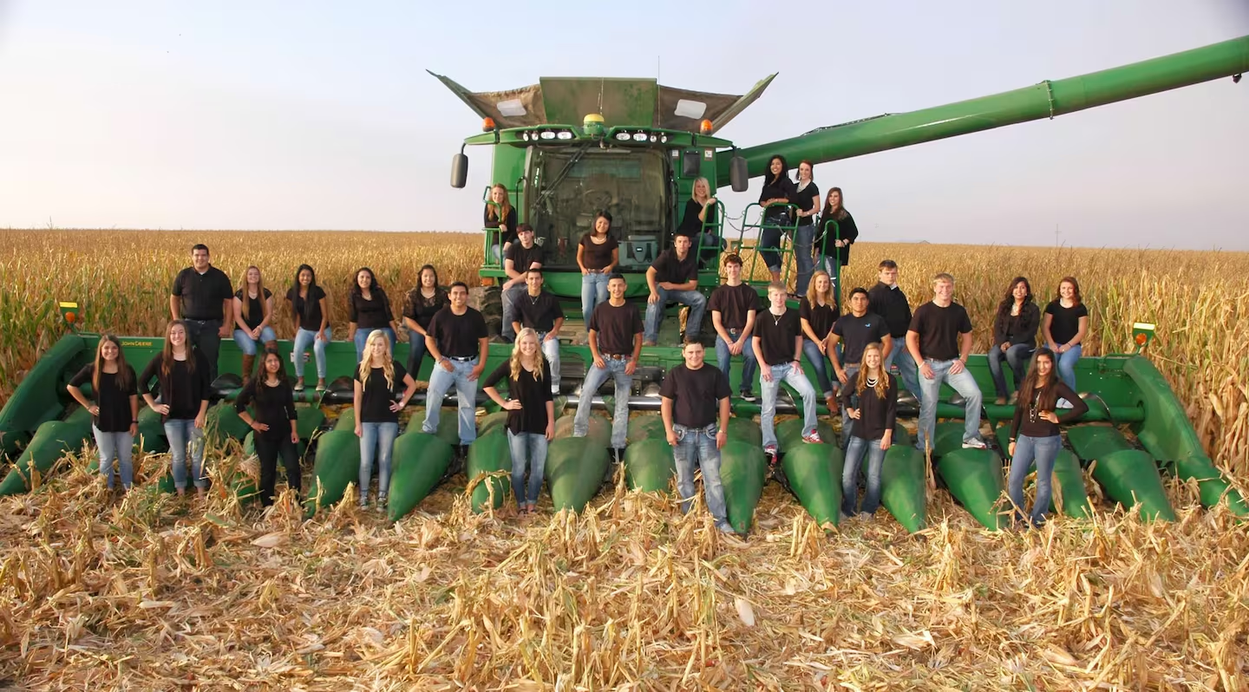
Gruver High School's Class of 2016 was the first group to receive scholarship funds. (Gruver High School)

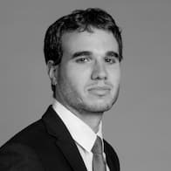 By Kyle Melnick
Leaders of a Texas school district didn’t know what to do with the precious and unusual gift they’d been given: 640 acres of farmland.
The school district in Gruver — a small farming city in the Panhandle — had been leasing the land to farmers to help pay for textbooks and beakers, but its leaders wanted to do something more ambitious with the land they inherited in 1984 from a longtime resident.
About 15 years ago, they met with local farmers at a high school football game.
What they came up with was more than ambitious; it was audacious. Farmers would volunteer their time and equipment to grow and sell crops on the land, and the proceeds would become college scholarship money for the city’s high school students.
In other words, residents would work for free on land that was not theirs to help other people’s children attend college. It would only work if most of the community of about 1,000 residents got involved in some way.
“Gruver is a unique community and is such a giving community that we just had a feeling it would work,” farmer Chad Logsdon said. “And it did.”
Farmers began planting millions of corn seeds and wheat berries around 2012, making about $400,000 from each year’s harvests. Students who graduated in 2016 were the first to receive scholarship money — up to about $40,000 for each student.
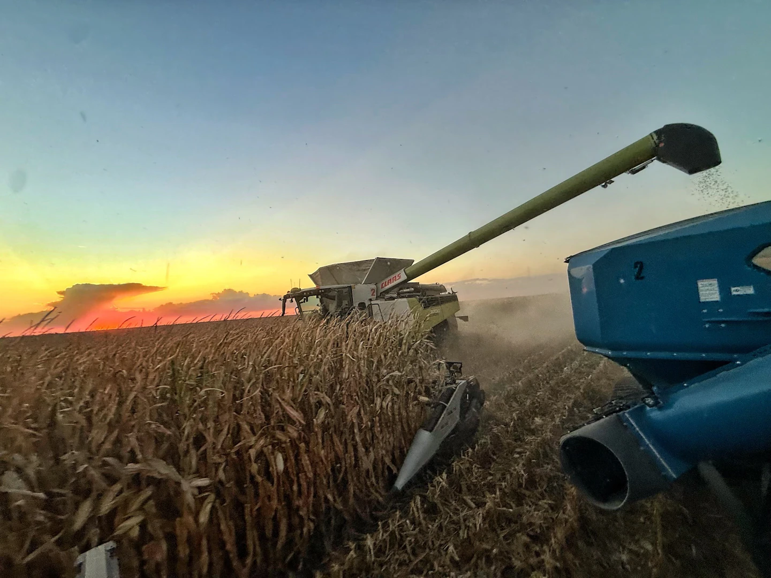Work on the farmland in October 2025. (Rhett Sparks)

Now, the school district has distributed nearly $3 million in scholarships to about 300 students. In just a decade, 48 students who received scholarship money became the first members of their family to graduate from college, according to the school district.
“It is unbelievable, the fact that the community will be willing to do this,” said Troy Seagler, Gruver High School’s former principal who helped come up with the idea.
The scholarship was founded around the same time student debt became a presidential campaign issue. One in four people with a student loan due is behind on their payments, and while some colleges have developed programs to help graduates repay their debt, Gruver’s fund might be one of the most creative approaches to tackling the issue facing about 42 million Americans.
Children in Gruver begin learning about the scholarships when they take field trips to the farmland in elementary school. On the plot sits a memorial for the man who donated the land, Karl Nielsen.
Children in Gruver, Texas, visit the farmland when they're in elementary school. (Gruver High School)
High school students earn points for strong grades and test scores, participating in extracurricular activities — like sports, the debate team and student council — and volunteering for community service. The more points they collect, the more scholarship money they secure.
The farmers, many of whom have lived in Gruver most of their lives, plant corn in the spring and wheat in the fall. They visit daily to ensure sprinklers are watering the plants properly.
“We just treat it like it’s ours — like it’s another one of our farms,” said farmer Derik Grotegut, who added that he took out student loans to attend West Texas A&M University after graduating from Gruver High in 2000.
When the plants are harvested, many bushels are sold to a Gruver feed yard, which pays more than the market value to add extra money to the scholarship fund, farmers said.
Some farmers have incentives beyond helping the city’s students: They want their children and grandchildren to have access to the scholarship fund.
Students who attended college and trade schools with the scholarship money have returned to the Gruver area as farmers, teachers, nurses, mechanics and accountants.
Sydney Ortiz, who graduated from Gruver High in 2023, dreamed about being a teacher since she was in elementary school, when she pretended to be a teacher with her siblings as her students.
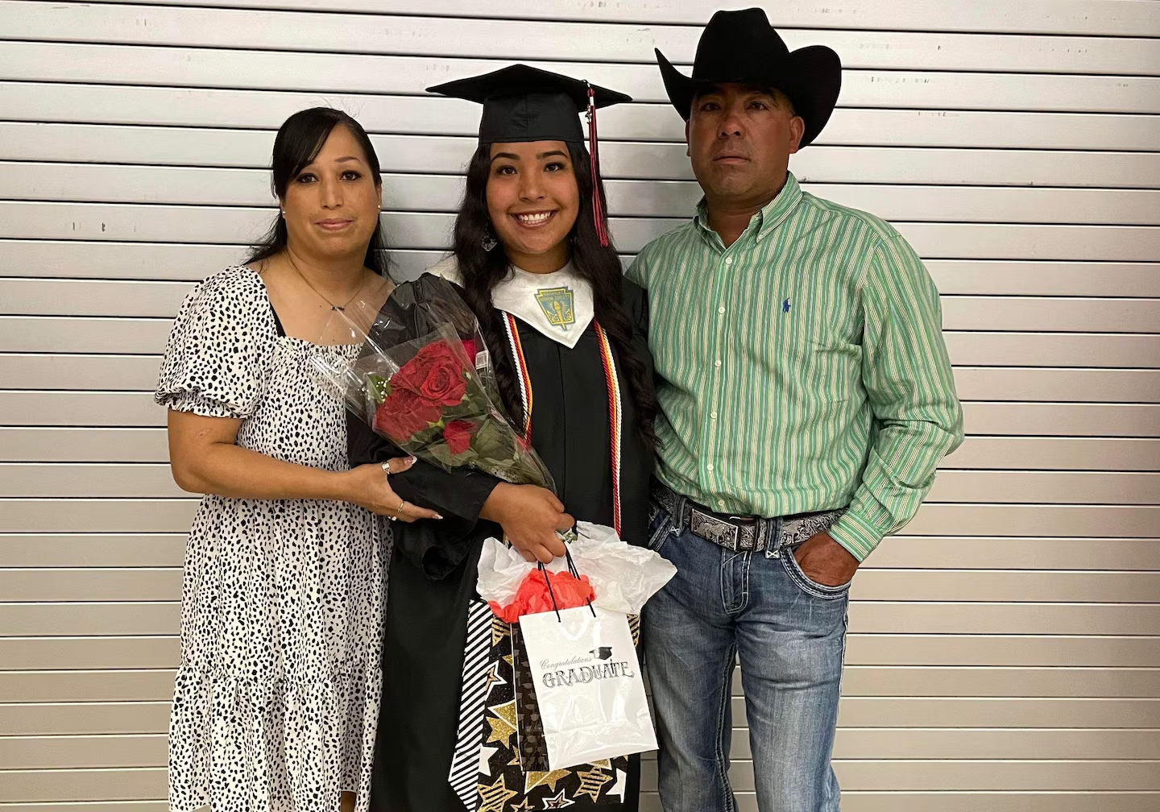Sydney Ortiz, seen with her parents Arturo and Lorena Ortiz, graduated from Gruver High School in 2023. (Courtesy of Sydney Ortiz)
Ortiz, who said her parents immigrated to the United States from Chihuahua, Mexico, in the mid 1990s, said she was worried that she couldn’t pay for college. Nobody in her family had graduated from college, she added.
In high school, Ortiz earned points through her grades, her participation in the National Honor Society and by volunteering at a local church and the school concession stand. She said she earned about $3,000 for each semester of her college tenure.
Ortiz, 22, is now a senior studying education at West Texas A&M University in Canyon, about 95 miles southwest of Gruver.
“I don’t think I would have been able to do that,” Ortiz said, “without the backbone of my family and my community.”
Rhett Sparks, who graduated from Gruver High in 2020, said he earned about $3,500 per semester from the scholarship fund, helping him graduate with an agriculture degree from West Texas A&M University in 2023.
Sparks, 24, returned to Gruver to work as a farmer and a pesticide applicator. Without the scholarship, he said he would probably be paying student loans.
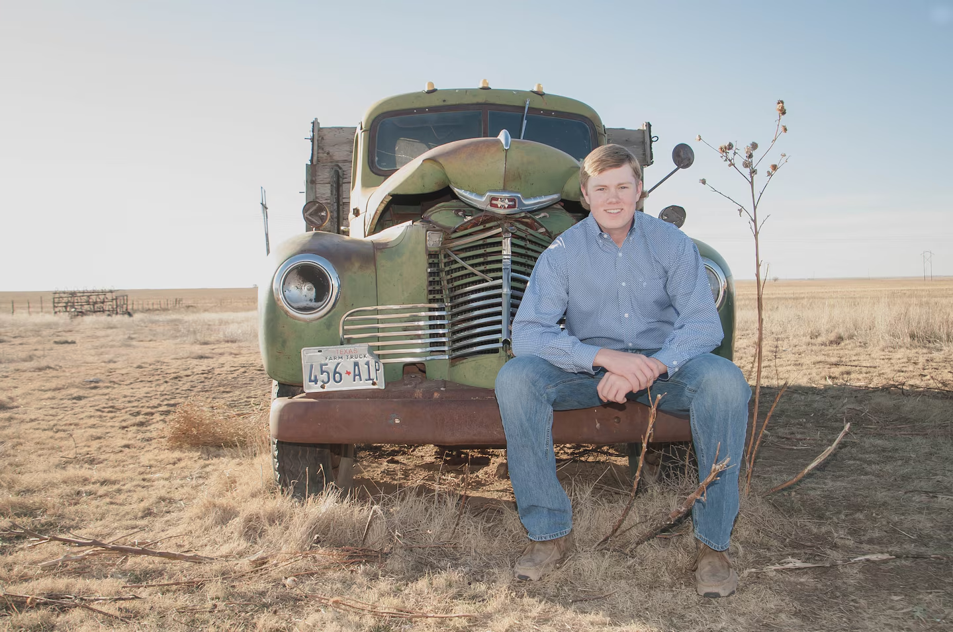Rhett Sparks graduated from Gruver High School in 2020. (Rhett Sparks)
Logsdon, another farmer, said some Gruver residents were initially concerned that farmers would get tired of volunteering their time.
But Sparks said he plans to help grow crops on the school district’s farmland for years to come.
“They helped me a lot,” Sparks said. “I want to return that back and help our kids.”
6. The Kindness of Strangers: In 1989 I lost a wallet with $1,000 in it. A couple went to incredible lengths to return it
- Link gốc: https://www.theguardian.com/lifeandstyle/2026/nov/02/kindness-of-strangers-lost-wallet-cash-returned-couple

The kindness of strangers: In 1989 I lost a wallet with $1,000 in it. A couple went to incredible lengths to return it
Cash was king in those days, and that money was enough to last me for a month as I slowly travelled from Australia back to the UK

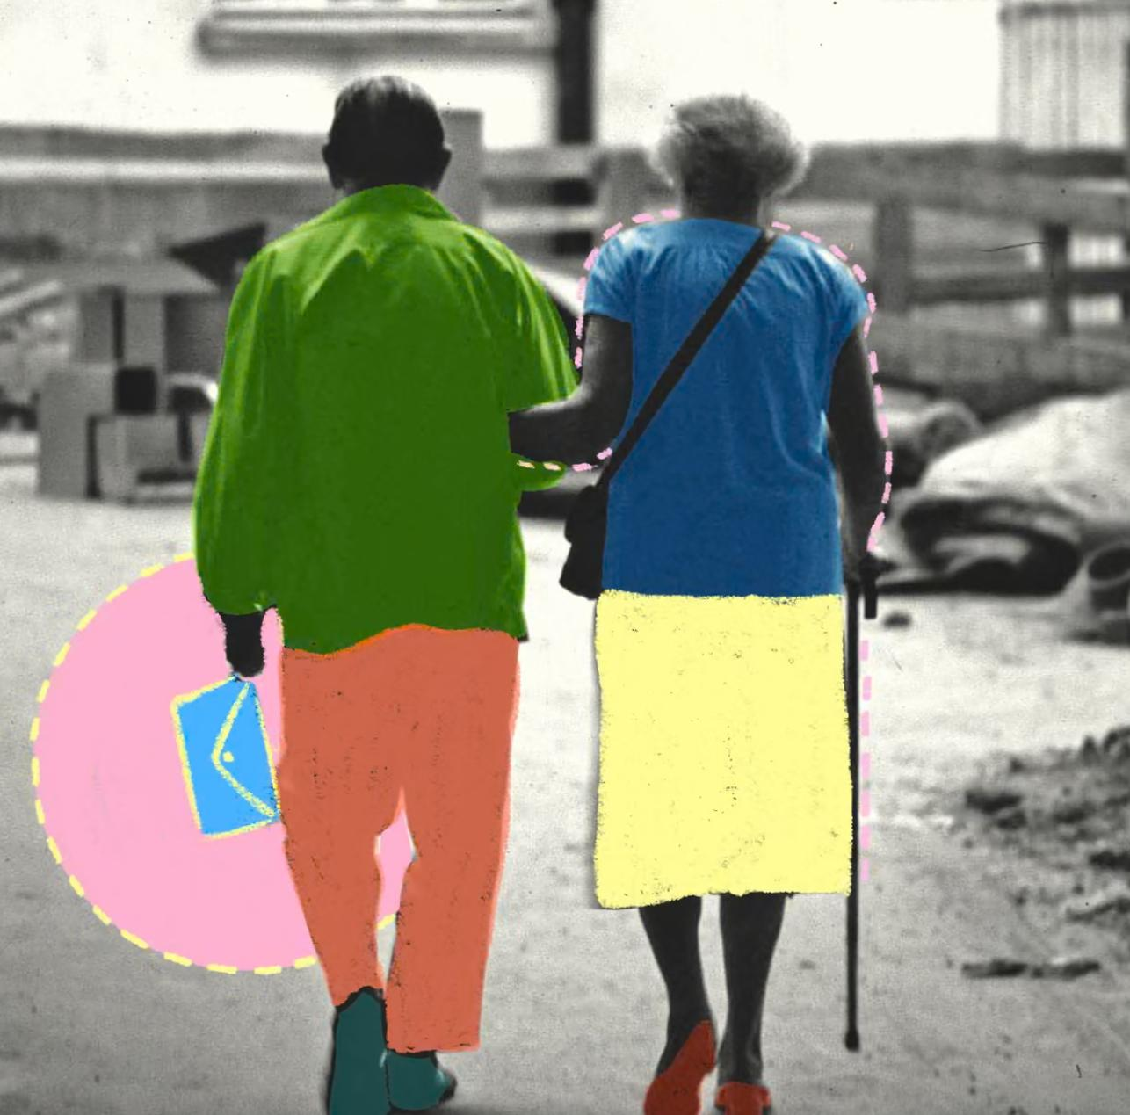
‘It wasn’t until the next morning that I realised the incredible lengths they had gone to in order to return my wallet.’ Composite: Victoria Hart/Guardian design/Getty Images

It was a hot night in 1989 when my wallet – stuffed with $1,000 cash – fell out of my pocket.
After university, I left the UK and went travelling in Australia for a year. I saw the delights of the east coast – mostly from various building sites, as I worked my way around doing long hours in the blistering sun. But I loved every minute of it. After 10 months, I had saved enough to make my way slowly back home.

I was enjoying one last night out in Darwin with a gang of traveller friends with whom I was flying to Timor the next day. The intention was to island hop all the way to Singapore.

Cash was king in those days, and the $1,000 I had in my wallet was enough to last me a month on the road. The beers went down easy and I was completely unaware when, at some point in the evening, I lost my wallet. I was still none the wiser when I went to bed to get some sleep before the flight the next morning.

At 1.30am, I awoke to a loud knocking on my door. I stumbled out of bed, bleary-eyed, and opened the door to the hostel manager and an elderly couple – who were holding my wallet.
That couple had spent hours trawling every backpacker place in Darwin (they’d been to four!) before eventually finding me, care of my student ID card. Every dollar was still there.

Still half asleep, and worse for wear after the evening’s drinks, I didn’t fully appreciate the extent of their kindness in the moment. I thanked them and went back to bed, but it wasn’t until the next morning that I realised the incredible lengths they had gone to in order to return my wallet. Without them, my trip would have been ruined.

I’ve always wished I could thank them properly, but in lieu of that I made a pledge to myself – and in a way, to them – that I would always go that extra mile to help people when I have the chance.
When I do get the opportunity to lend someone a hand, I always tell them to pay it forward. So I like to think that kind couple in Darwin have actually helped countless others, too.

7. Gánh mưu sinh:
https://e.vnexpress.net/news/travel/places/street-vendors-with-shoulder-pole-a-familiar-sight-in-vietnam-s-old-town-4099491.html

Street vendors with shoulder pole a familiar sight in Vietnam's old town
By Do Anh Vu, Huynh Phuong May 15, 2020 | 04:52 pm GMT+7
Get VnExpress first in Google Search
The bamboo shoulder pole with baskets filled with agricultural produce and other wares could well be the leitmotif of Hoi An.
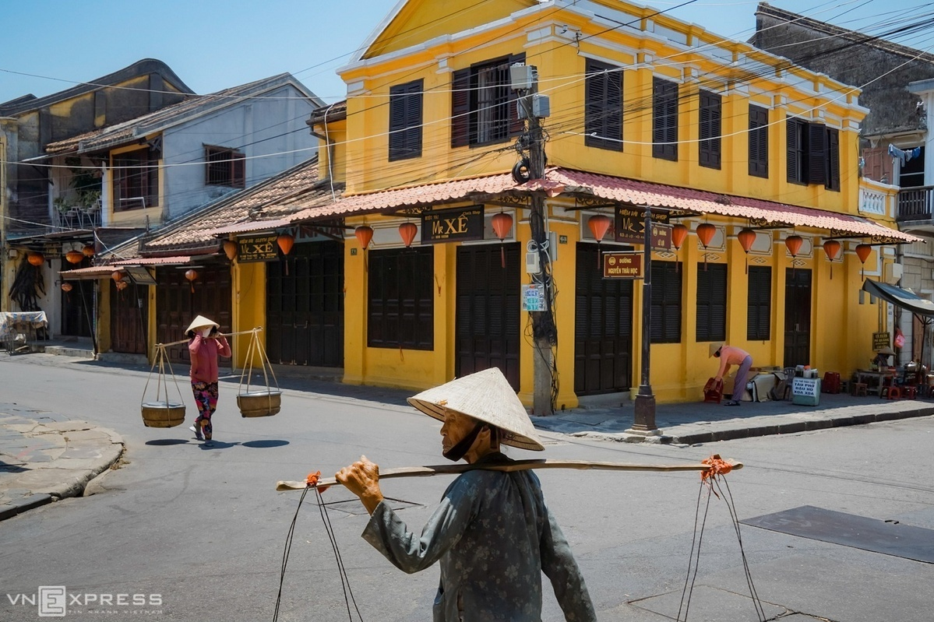
Two women with baskets on their shoulders at the intersection of Nguyen Thai Hoc and Le Loi streets. The photos by Do Anh Vu show the langorous pace of life in Hoi An, a popular tourist destination in central Vietnam.
The bamboo shoulder pole, quang ganh, has for long been a useful piece of equipment for Vietnamese farmers in the countryside to carry their produce and earn a living on the streets of cities, and is a familiar sight in the ancient town of Hoi An.

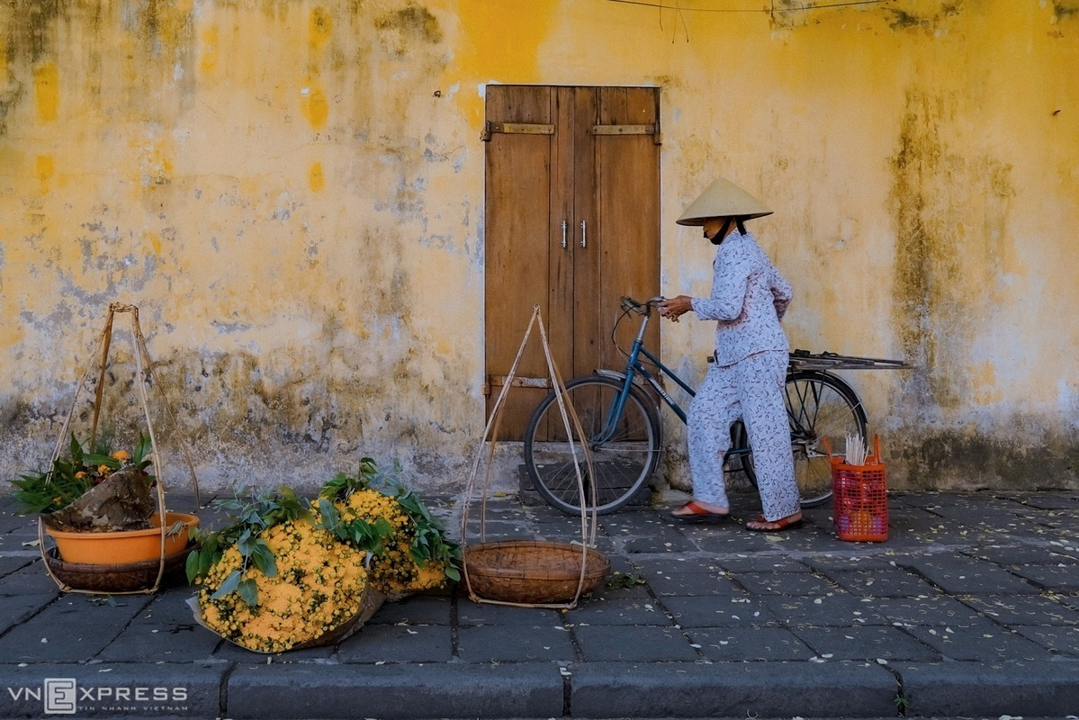
Chrysanthemum flowers sold on a sidewalk of Hoang Van Thu Street.

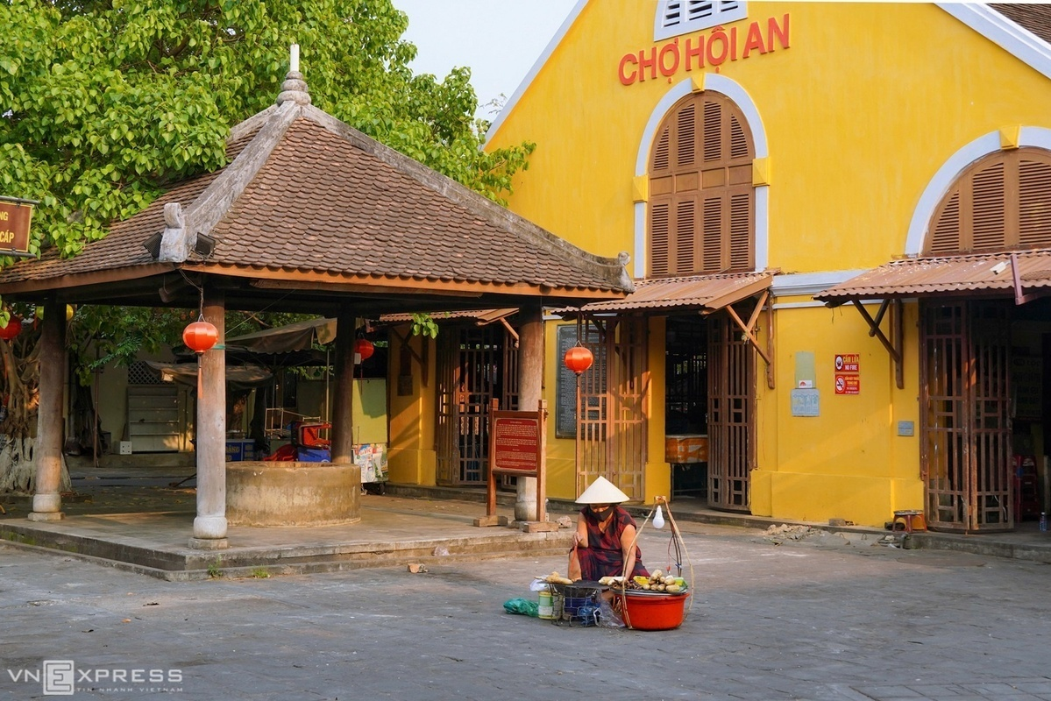
A woman sells grilled corn outside the deserted Hoi An Market. The picture was taken on April 6, when the country was in the midst of the social distancing campaign meant to contain the Covid-19 pandemic.

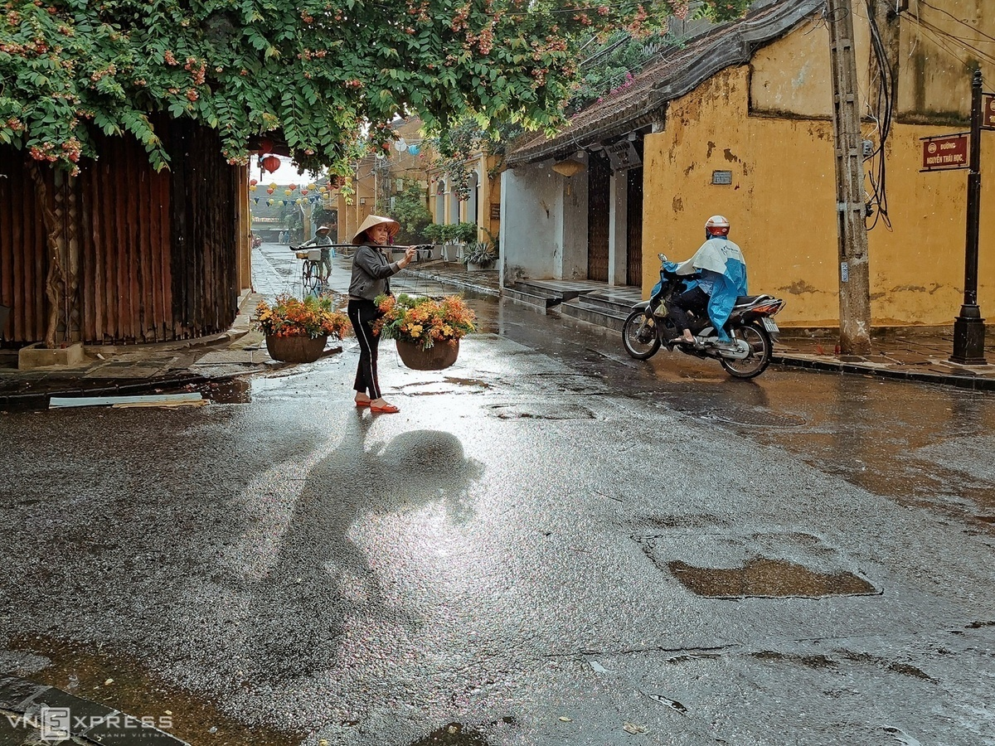
A woman carrying flowers walks in the rain at the junction of Hoang Van Thu and Nguyen Thai Hoc streets.

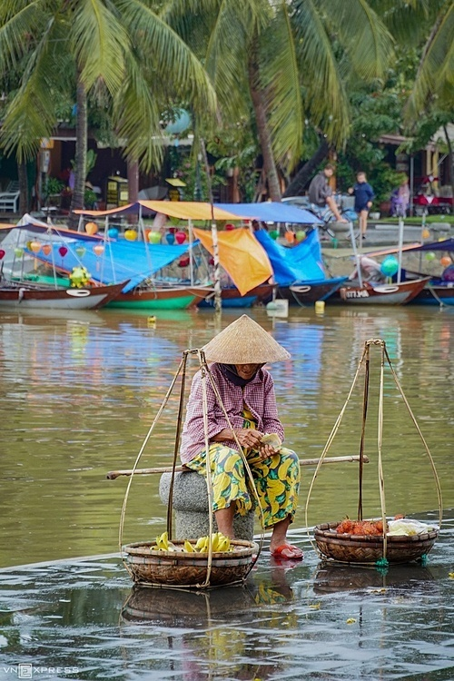
An old lady sells bananas on Bach Dang Street by the iconic Hoai River that flows through the town.

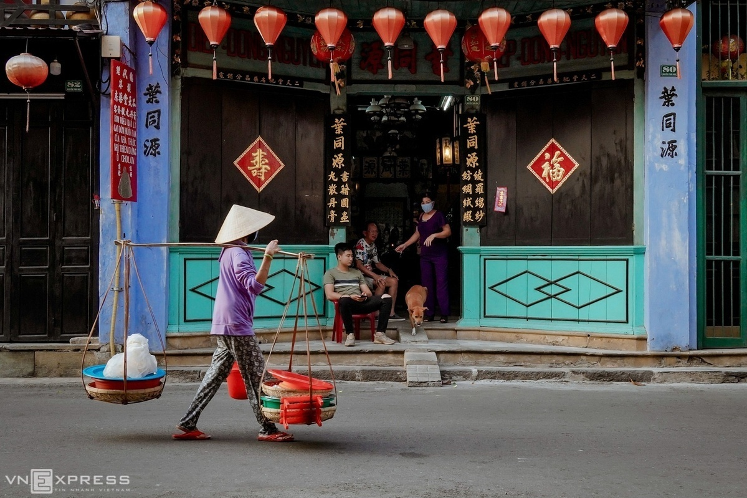
A woman with a basket of rice crackers walks past a Chinese-style house on Nguyen Thai Hoc Street.


On the town’s streets, visitors can often see women carrying a quang ganh on their shoulders and hawking their wares. They usually sell bananas, grilled corn, tofu, duckweed, pound cakes, and fresh flowers.

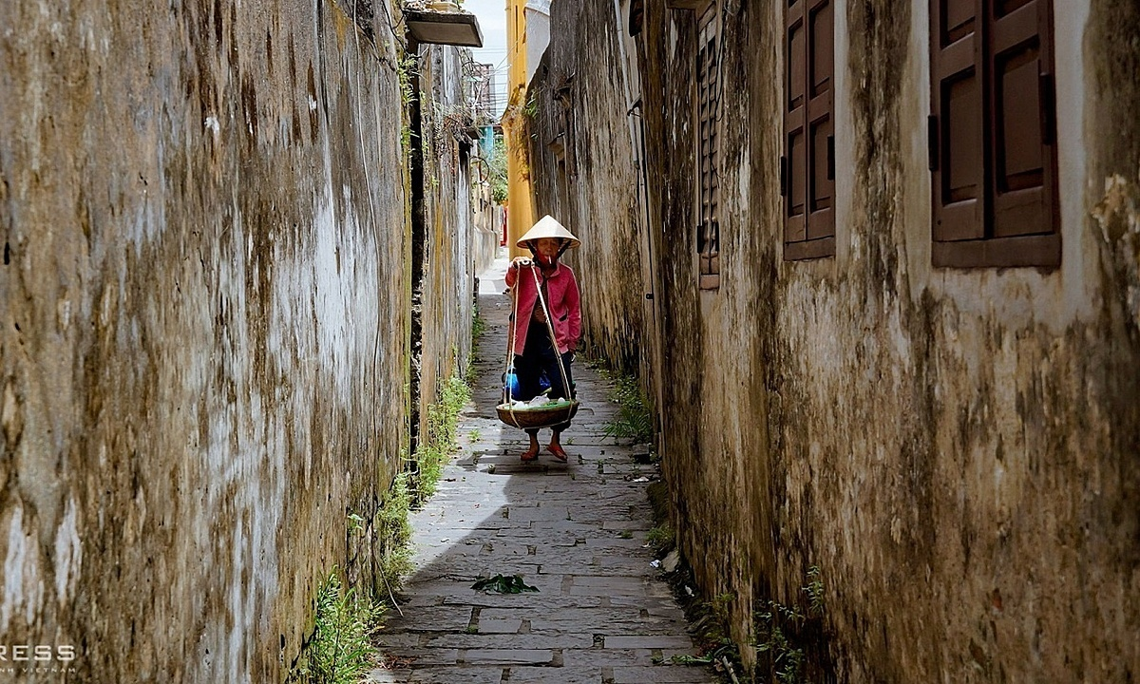
A woman with a quang ganh walks in a tiny moss-covered alley.

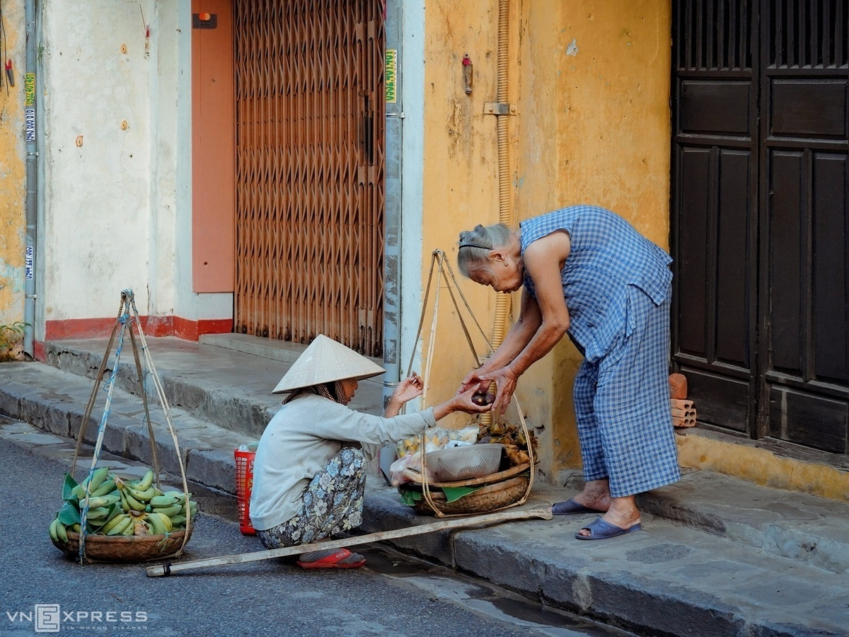
A hawker sells sweet potatoes on Tran Phu Street.

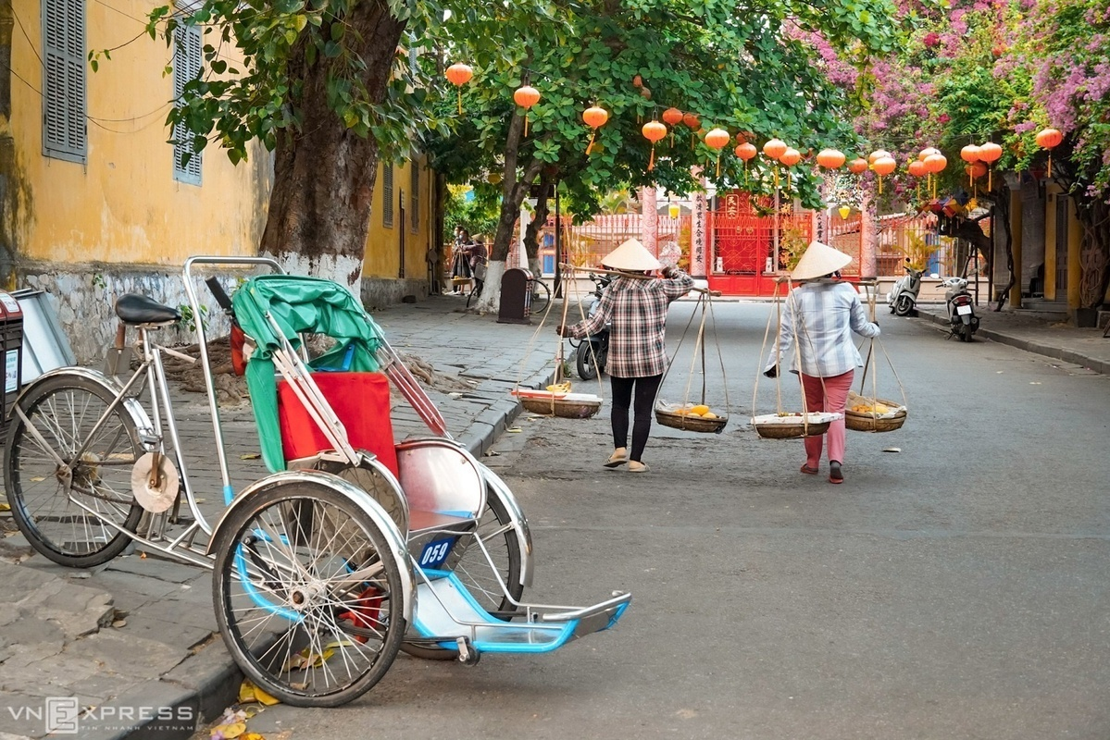
Two women carrying baskets of fruits walk along Chau Thuong Van Street.
Hoi An has been a pioneer of pedestrian-friendly streets in the country since 2004. Motorbikes and cars are banned from the town center from 9 a.m. to 11 a.m. and 3 p.m. to 9:30 p.m. Most hotels, restaurants and homestay facilities rent bicycles.

8. On World Kindness Day, how one nonprofit has given the gift of mobility to 1.5 million people (Quỳnh)
The nonprofit has given 1.5 million wheelchairs to people in 95 countries.
ByMason Leath
November 14, 2025, 6:38 AM
One nonprofit is changing lives worldwide — one wheelchair at a time.
https://abcnews.com/video/127480629/
On World Kindness Day Thursday, Free Wheelchair Mission is one philanthropic organization building and delivering wheelchairs to people with disabilities around the world.
The nonprofit has given 1.5 million wheelchairs to people in need in 95 countries since 2001, according to their website, describing their company as "a humanitarian organization that designs and manufactures cost-efficient, durable wheelchairs for individuals living with disabilities in developing countries."
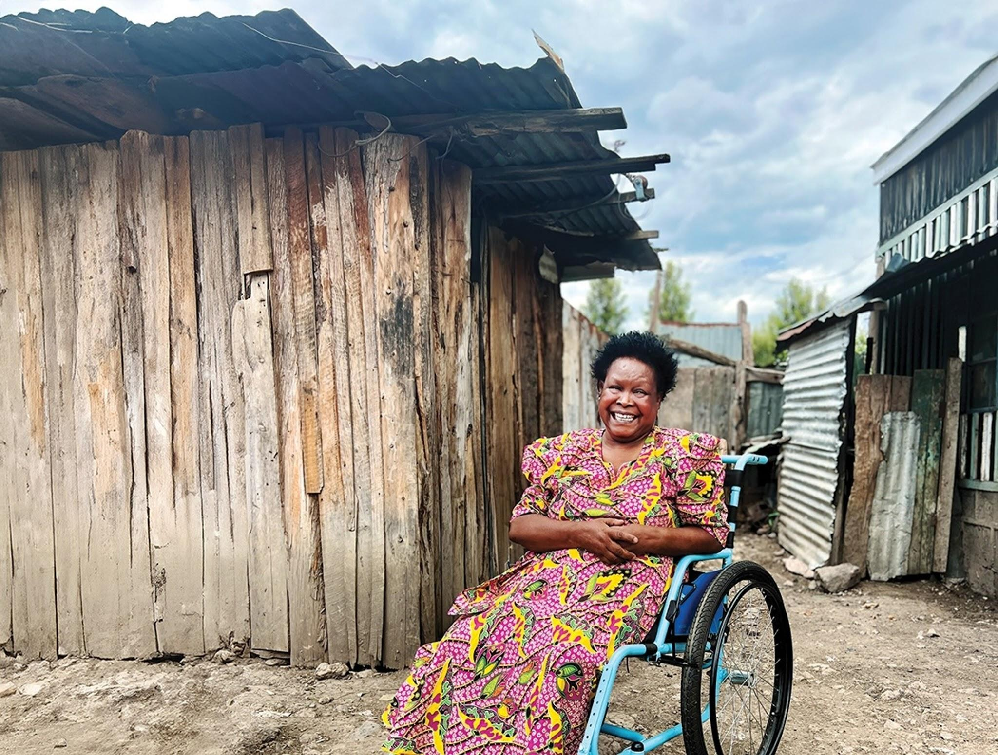
Anna is shown with her wheelchair in Kenya.
Nuka Hart, the CEO of Free Wheelchair Mission, told ABC that their goal is to provide free wheelchairs across the globe.
"There are 80 million people that need a wheelchair at any given time, and our mission is to provide those wheelchairs for free," Hart said.
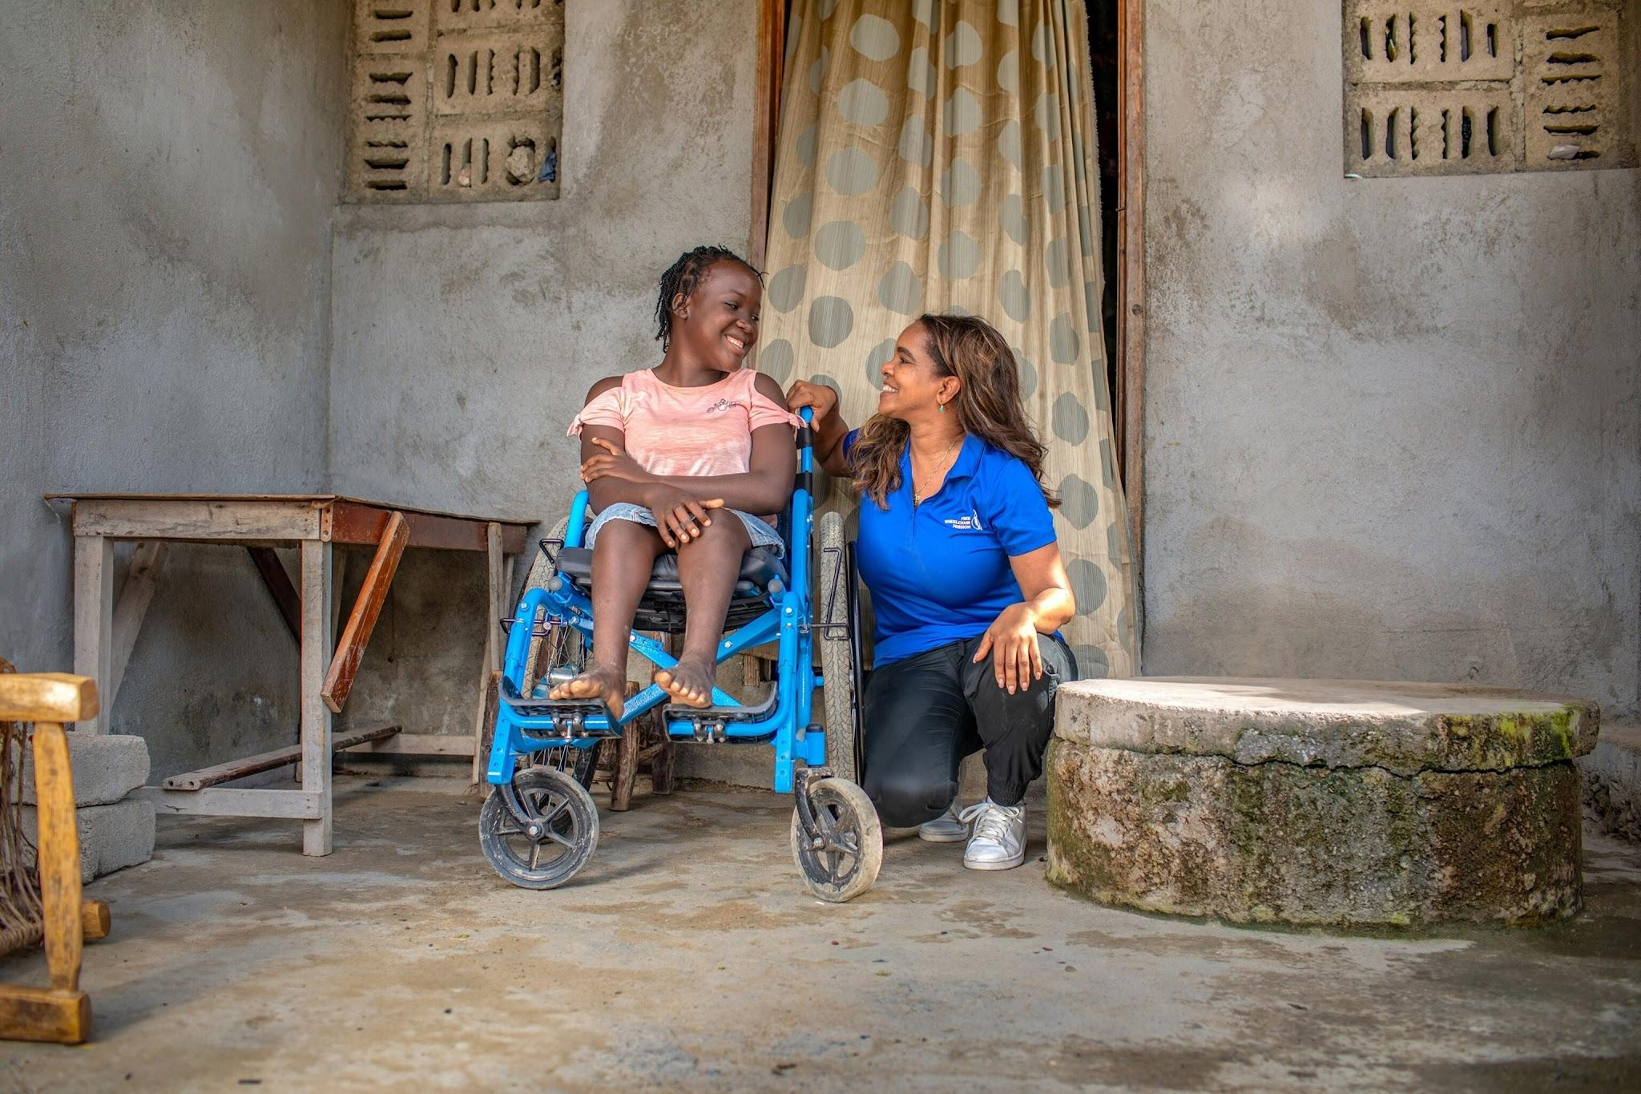
Nuka Hart, CEO of Free Wheelchair Mission is shown with Fabienne Joseph, a wheelchair recipient in Haiti.
Ulises, 16, who lives in Argentina with Cerebral Palsy, was one of the first to receive one of Free Wheelchair Mission's latest foldable wheelchairs, the GEN 4 JOY, in June. He told ABC how the wheelchair has changed his life.
"This wheelchair changed me, it truly changed me," he said. "Yes, I have a disability, but I accept myself how I am, this reinforces how I am important, and how much I really have to give back to the world."
Cerebral Palsy (CP) "is a group of disorders that affect a person's ability to move and maintain balance and posture," according to the CDC.
"CP is caused by abnormal development of the brain or damage to the developing brain that affects a child's ability to control their muscles," their website reads.
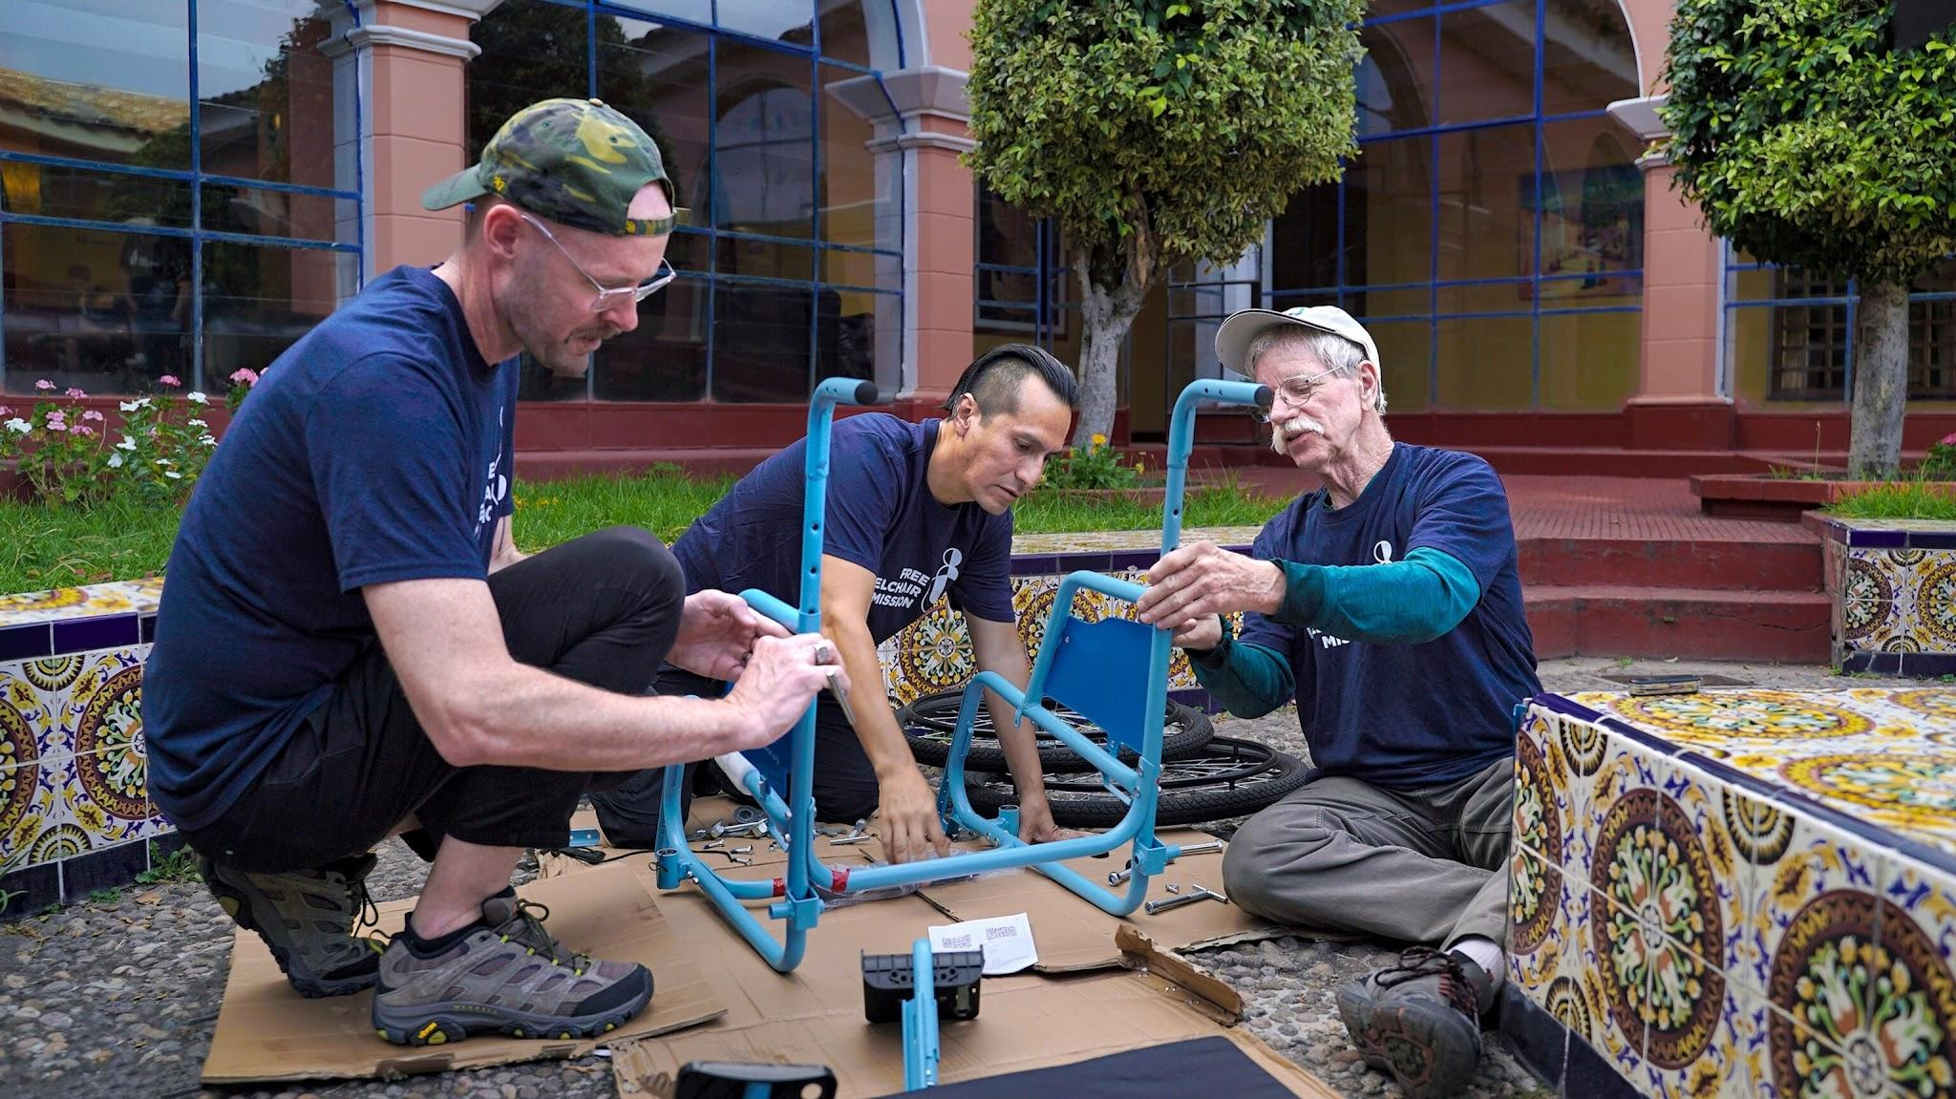
Don Schoendorfer, Free Wheelchair Mission founder and president, (R), assembles a wheelchair with Clever Sobrino and Pastor Taylor Barriger, in Peru.
Free Wheelchair Mission's GEN 4 JOY wheelchairs are designed to last longer and be more efficient to produce.
"With its more modern design and robotics integrated into the factory production line, GEN 4 JOY also enables increased production efficiency and reduced costs for shipping wheelchairs internationally to all the countries the organization serves," a press release about the wheelchairs says.
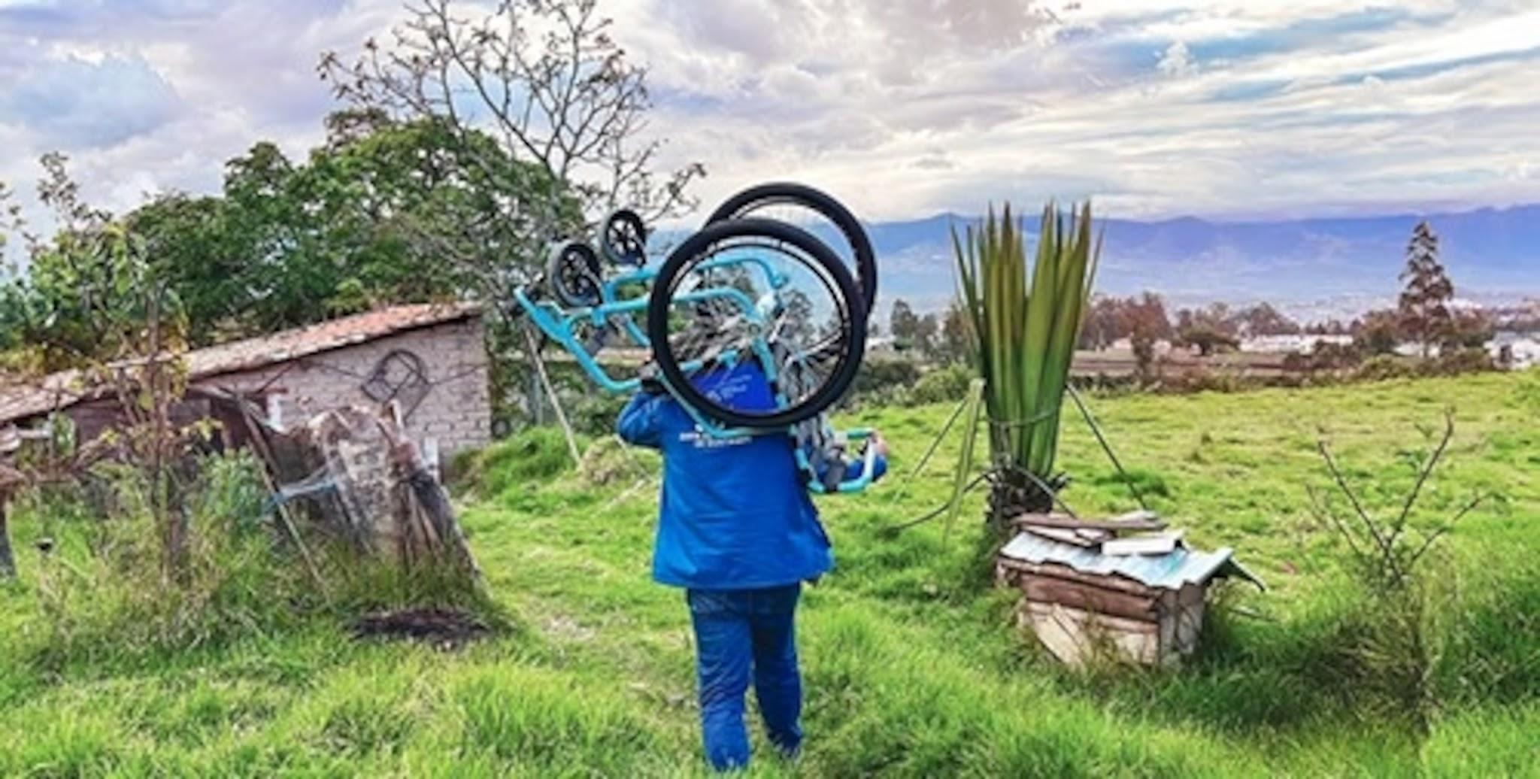
A worker with distribution partner Junta de Beneficencia de Guayaquil delivers a wheelchair in Ecuador.
"Wheelchairs provide mobility, which changes everything: it means independence, the ability to participate in society and earn a living. Mobility means renewed dignity, independence, and hope," their website reads.

8. Stable electricity brings light to homes in remote village https://vietnamnews.vn/society/1803487/stable-electricity-brings-light-to-homes-in-remote-village.html
More than 400 households, representing up to 1,571 residents, have benefited from a rural electrification project implemented in Quảng Trị Province's Bồng Lai Village between 2014 and 2020.
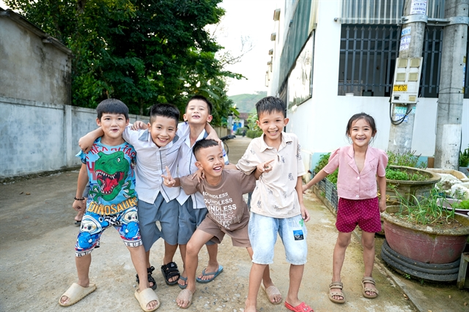
Children in Bồng Lai Village, Quảng Trị Province's Bố Trạch Commune. Since the village was connected to the national power grid in 2020, life has been much improved thanks to power stability. Photo courtesy of the EU
Nguyễn Khánh Chi
QUẢNG TRỊ - Hoàng Văn Thảo hopped off his electric motorbike and hurried inside to welcome a group of visitors at his home in Bồng Lai Village, in Quảng Trị Province’s Bố Trạch Commune.
Instead of crouching over a charcoal stove to boil water for tea, he walked to an automatic hot-water dispenser in a corner of his spacious two-storey concrete house and filled the cups within seconds.
“Now that the electricity supply is stable, we can use them all,” Thảo said, gesturing around the house.
“We have a washing machine, refrigerator and air conditioner, along with everyday appliances such as a television, gas stove and induction cooktop.”
The 56-year-old's family is among 412 households, representing up to 1,571 residents in the village, that have benefited from a rural electrification project implemented in Quảng Trị Province between 2014 and 2020.
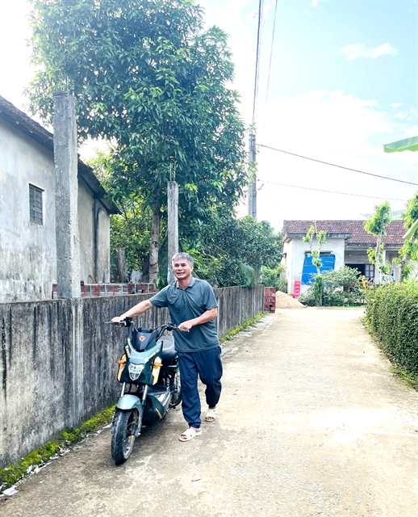
Hoàng Văn Thảo, 56, with his family's electric bike. Stable electricity supply has enabled him to equip the family with multiple electrical devices. VNS Photo Khánh Chi
Under the sub-project, which had a total investment of nearly VNĐ73 billion (US$2.83 million), around VNĐ60 billion was provided through non-refundable EU funding, with the remainder contributed by the provincial government as counterpart capital.
Implemented in 2019–2020, the project supported the expansion and upgrading of electricity infrastructure in six communes across former Bố Trạch and Minh Hòa districts. Key investments included 10.35km of medium-voltage power lines, 84.91km of low-voltage lines, 16 new transformer substations with a combined capacity of 2,200 kVA, and the upgrading or relocation of five existing substations.
“Through the Vietnam – EU Sustainable Energy Transition Programme, the province has achieved many positive results in renewable energy development and the expansion of electricity supply infrastructure in rural and mountainous areas,” said Deputy Chairman of the Provincial People’s Committee Lê Đức Tiến.
“Extending the national power grid and bringing clean energy sources to villages and hamlets have significantly improved local people's living conditions and livelihoods while laying a solid foundation for green economic development and greenhouse gas emission reduction in line with the Government's overall objectives.”
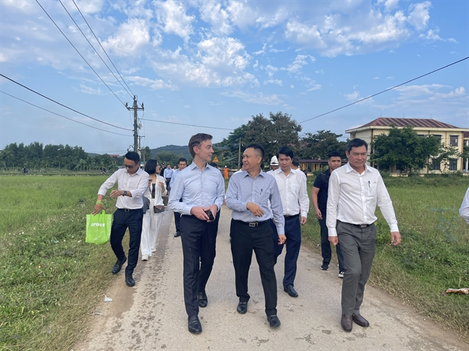
EU Ambassador to Việt Nam, Julien Guerrier (front, left) and Deputy Minister of Industry and Trade Nguyễn Việt Sơn conduct a site visit to Bồng Lai Village in October, 2026 to examine electricity supply there. VNS Photo Khánh Chi
Over the years, the EU and Team Europe have been key partners in supporting rural electrification in Việt Nam, particularly in remote, mountainous and island areas.
In the 2018-2020 period, the EU has invested in the Energy Sector Policy Support Programme 108 million euros ($120.8 million) to provide sustainable energy in rural Việt Nam in the 2018 – 2020 period.
“This programme aimed to provide electricity access for up to 1.2 million Vietnamese households, including in particular in remote areas, and to expand electrification to around 750 villages across the country,” said the EU Ambassador to Việt Nam, Julien Guerrier, during a recent site visit to Bồng Lai Village.
“It's a very rewarding project because we can see the happy faces of the villagers who have now access to electricity in a stable manner. It's benefiting their daily life, but also their businesses and their farming capacity.
“I think we can be proud of what has been achieved here in Quảng Trị and in so many other provinces. Through the electrification of the countryside, we've been able to improve the life of communities, including in rural areas and in remote parts of the country.”
For father of three Thảo, quality of life has been much improved not only thanks to electricity but also to the advanced economic development and transport system in the locality.
“The electricity is very reliable, and we can use it comfortably," he said.
"Since electricity became available in 2020, our quality of life has improved because the economy has also developed, and transportation has become more convenient.”
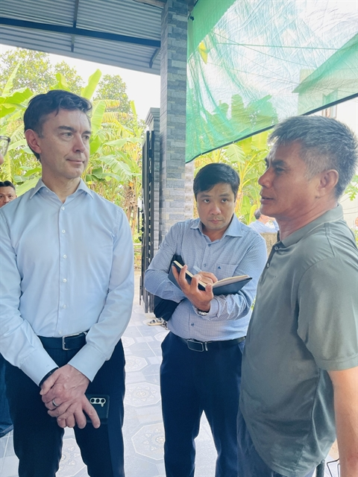
Hoàng Văn Thảo (right) speaks to the EU Ambassador to Việt Nam, Julien Guerrier about his living standards which have been much improved thanks to stable electricity supply. VNS Photo Khánh Chi
“In the past, the electricity supply was unstable, and life was very difficult. Often we could only use lamps because the power kept going on and off. Now that we have reliable electricity, it is much easier for the children to study at night.
"The family can also enjoy watching television every evening, which broadens our knowledge.
“Before, we used to go to bed around 8 or 9pm. Now, with electricity, we watch TV or use our phones until 10 or 11pm.”
In addition to household use, his family also uses electricity to power two water pumps for agricultural production, mainly for irrigation of their pepper, tea, acacia and melaleuca plantations. With all these devices, the family spends about VNĐ700,000-800,000 ($27-31) on electricity each month.
As head of Bồng Lai Village, Nguyễn Văn Sơn, has witnessed firsthand life before and after local power was connected to the national grid.
"Before the project, local communities faced many challenges due to an unstable electricity supply," said Sơn.
"Since being connected to the national power grid, residents have gained access to a safer, more stable, and more reliable source of electricity. This has significantly improved both living conditions and economic opportunities throughout the area."
According to the village head, the power supply has enabled households to purchase and use modern appliances such as televisions, refrigerators and other electrical equipment with greater confidence.
At the same time, stable electricity has supported the expansion of agricultural production, livestock farming, and small businesses, encouraging residents to invest in income-generating activities.
Sơn added: "In the past, power outages were frequent, often caused by tree branches coming into contact with the power lines, leaving entire communities without electricity overnight.
"Today, thanks to the upgraded electricity network, such disruptions have become rare, providing residents with a much more dependable source of power."
These improvements have translated into tangible economic benefits. Average annual income has increased from approximately VNĐ38 million ($1,476)toaroundVNĐ65million($2,520) per person, reflecting the positive impact of reliable electricity on local livelihoods and economic development.
Despite these efforts, provincial authorities have reported that electricity is still out of reach in some parts of Quảng Trị Province due to terrain challenges.
The locality is calling for the Ministry of Industry and Trade to allocate certain funds for projects to help connect these areas to the national power grid.
According to the Quảng Trị Department of Trade and Industry, currently, 19 villages and hamlets in Quảng Trị have no connection to the national grid, while 18 villages and hamlets have electricity supply that does not meet the requirements.
That equates to 832 households without grid electricity, and 243 households supplied by systems that do not meet the requirements. VNS

